MERRITT BENCH ELEMENTARY SCHOOL
SUPPLY LIST FOR GRADE 6
2-4 whiteboard pens (not black)
Pencils (8)
Glue stick
2 sharpies (fine liner & medium)
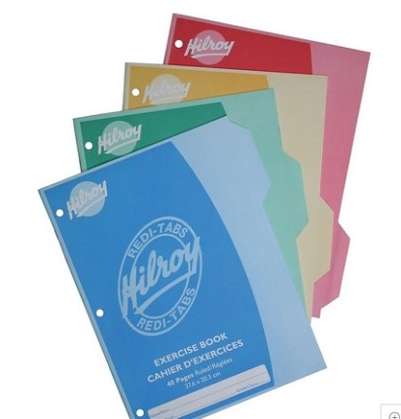

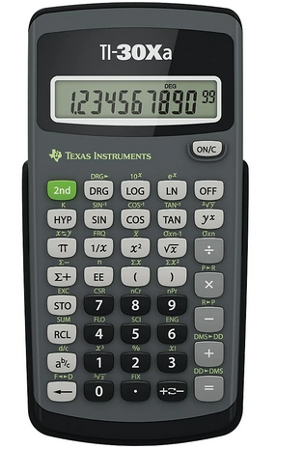

Calculator (Texas Instruments, Casio or Sharp) cost is $15.00 +/-
No binder
Plastic see-through ruler
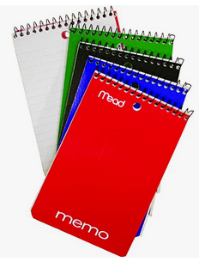Pencil crayons
Small note pad
2 Hi-liters
Pencil case
White pencil eraser
8 Duo-tangs
1 Pkg Loose Leaf Paper (150 sheets)

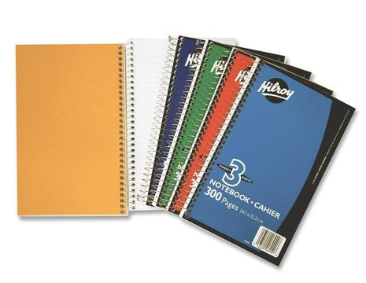6 Key-tab notebooks
2 – Three subject notebooks (good quality)
Good scissors
Wireless mouse / Flashdrive / TNRD Library Card
1 box of Kleenex

Gym Strip (running shoes, shorts, T-shirt) in gym bag with pull string.
PLEASE MARK EACH ITEM WITH YOUR CHILD’S NAME OR INITIALS.
Bring ALL supplies to school - Extras will be stored in marked envelopes and given out as needed.

Please make sure all shoes have a sole that doesn’t leave scuff marks on the floor.
Students should keep their indoor running shoes for P.E. and indoor use only, and should have a second pair of shoes to wear outdoors and back and forth to school.

*This is a basic supply list. Your child’s teacher may request additional supplies in September.

