MERRITT BENCH ELEMENTARY SCHOOL
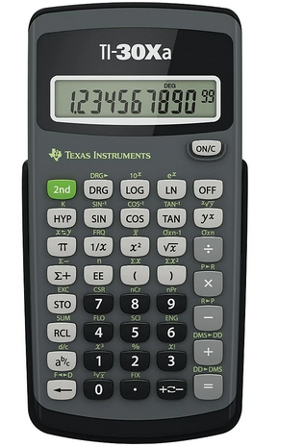
SUPPLY LIST FOR GRADE 6
2-4 whiteboard pens (not black)
Pencils (8)
Glue stick
2 sharpies (fine liner & medium)
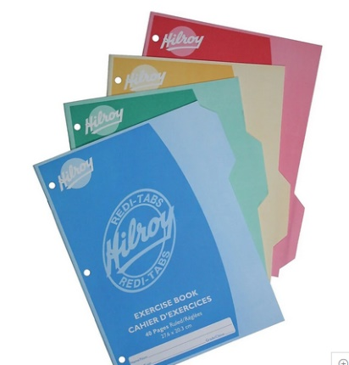
Calculator (Texas Instruments, Casio or Sharp) cost is $15.00 +/-
No binder
Plastic see-through ruler
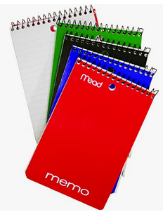
Pencil crayons
Small note pad
2 Hi-liters
Pencil case
White pencil eraser
8 Duo-tangs
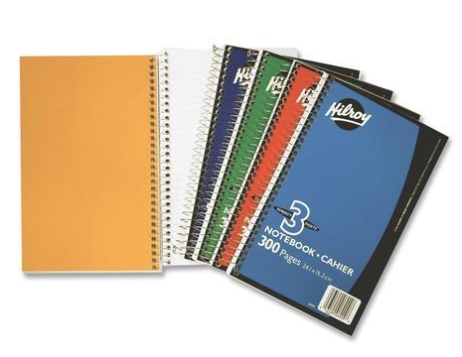
6 Key-tab notebooks
2 – Three subject notebooks (good quality)
Good scissors
Wireless mouse / Flashdrive / TNRD Library Card
Gym strip (Indoor gym shoes/shorts/t-shirt)
1 box of Kleenex
1 Pkg Loose Leaf Paper (150 sheets)

